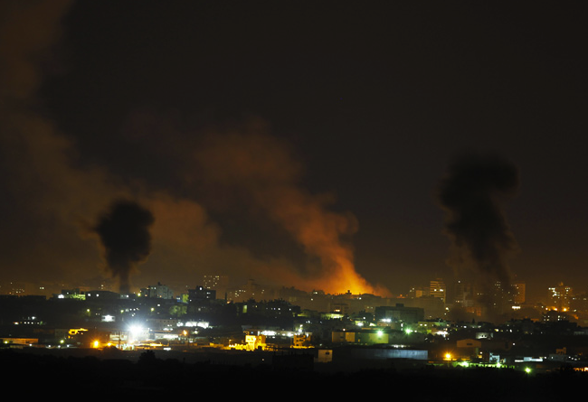
Gaza Strip night of November 14

Gaza is under attack and in need of medical support
Many children injured, many the difficulties of managing the emergency, and very black forecasts.

The children were among the first victims, hit while playing football, and already more than once since November 8.
Others in their parents' lap, others wounded.

Children's hospitals and emergency services of general hospitals are, as always, for the block and the slavery imposed on the population, below the level of medical supplies essential and necessary and in the impossibility to deal without support with emergencies.

In these moments you need to ally in order to be effective, so we ask you to donate funds for this emergency and we agreed to send aid through Medical Aid for Palestine, and organization that for years supported the work of Palestinian Doctors and, that in this moment of emergency are able to use them at the best having already drawn the map of emergency needs.

We ask you to help in emergency immediately with your generous contributions.

Genoa, 15 November 2012
Appeal for Gaza's children

Fundraising at www.Maniverso.org,
look for the banner of the appeal for the children of Gaza and referred to – write as the reason for the donation : emergency appeal - these funds will be kept separate from those of donations for structural aid-

and if you want to donate, do it immediately, so we can act now

November 9 Ahmid Younis Abu Dakka, killed while playing soccer in the yard
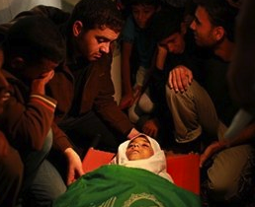
November 12 wounded children at Shifa Hospital
